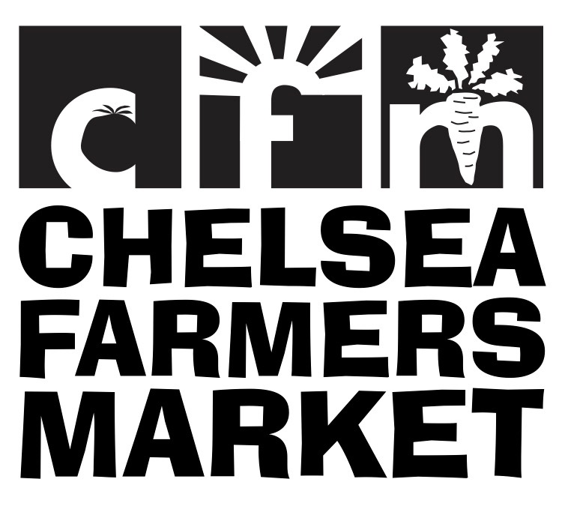
CFM POP-UP CAFÉ Application 2019
Please PRINT & RETURN this page to: PO Box 126 Chelsea, VT 05038 OR scan and return by email.

The Chelsea Farmers Market (CFM) takes place on Fridays from 3:00-6:00 PM on the North Common,
in Chelsea. Please contact the manager at manager@chelseafarmersmarket.org or call Jennie at 802-685-4841 with any questions.
Business Name if applicable
Individual Contact Name
Mailing Address
Email
Phone #
Type of food offered | Please describe
Please circle the date of each market you would like to attend in 2019. Any highlighted dates are taken.
May | June | July | August | September
17 | 7 | 5 (Holiday Weekend) | 2 | 6
24 | 14 | 12 | 9 | No Market, Tunbridge Fair
31 (Spring Fest) | 21 (Kids Vend!) | 19 (Kids Vend!) | 16 (Kids Vend!) | 20 (Harvest Fest)
 | 28 | 26 | 23 | 27
 |  |  | 30

PLEASE NOTE: The same vendor is not permitted to host the café more often than 1 x per month according to the regulations of the VT Agency of Health which allows for a waiver of rules for food service vendors who only vend periodically (less often than 1 x per month.)

If you are a day vendor (as opposed to a seasonal vendor) you will be asked to pay a fee of $30.00. per event: $15.00 is the day vendor fee to have a table at CFM, the other $15.00 is to offset the cost of the materials provided (see following page).
Café vendors who have already paid a seasonal fee for the market will only be required to pay the additional $15.00 equipment fee.
Fees will be waived for any vendors planning to donate their profits to the market. All fees are payable by check or cash at the time the application form is submitted to the market manager.

I have enclosed my vendor fee for each of the dates I have selected. I agree to abide by the rules of the Chelsea Farmers Market.

Name:
Date:

Please keep the following 2 pages for your records

CFM POP-UP CAFÉ Application

CFM takes place Fridays from 3-6pm on the North Common, in Chelsea. Please contact the manager at manager@chelseafarmersmarket.org or call Jennie at 802-685-4841 with any questions.

Type of food offered | Please describe

Vending Dates Requested

May | June | July | August | September
17 | 7 | 5 (Holiday Weekend) | 2 | 6
24 | 14 | 12 | 9 | No Market, Tunbridge Fair
31 (Spring Fest) | 21 (Kids Vend!) | 19 (Kids Vend!) | 16 (Kids Vend!) | 20 (Harvest Fest)
 | 28 | 26 | 23 | 27
 |  |  | 30

How the Chelsea Farmers Market Café Works
The Chelsea Farmers Market will put up two tents for the Café, one for the vendor to set up food and serving items and a second tent with picnic tables and benches for customers to eat in the shade.

Vendors will be provided with the basic requirements needed to operate a food service café at the Farmers Market, except for food, serving utensils, ice and ice chests, plus some types of cooking equipment (e.g. a grill/ smoker etc. depending on the type of food being sold)

This includes: 3 folding 6ft tables; Compostable plates, to-go containers, ‘silverware’, and napkins; Compostable beverage containers; Single-use non-latex gloves; Deli tissue, spatulas, and tongs; Chafing dishes to keep food warm; Electricity if needed; Trash can and compostable trash bags; Cleaning materials.
The tables will be kept at the back of Mary Reilly’s shop on the North Common. Vendors are expected to pick them up from Mary’s and return them in a clean condition ready for the next week’s vendor to use.
Additional items will be delivered in plastic totes to the Café area at the time the tent is set up. If chafing dishes need to be cleaned after use p-lease check w/ market manager for inbstructions.

Chelsea Farmers Market Policies re. Prepared Foods

- Sellers of prepared foods must follow State health laws and should not handle food with bare hands; State health regulations require that prepared food be covered, and that any perishable food be kept adequately chilled or heated.
- Each vendor is responsible for any licensing or certification required for products sold.
- Liability insurance is also the vendors responsibility.

Full CFM rules and regulations may be viewed and downloaded from our website: www.chelseafarmersmarket.org/sell

Rainy-Day Policy
  - If the forecast is for a severe storm warning (i.e. hurricane, lightning, hail, etc.) in our area that seems very likely to hit us, we will cancel the market by 12 noon on the day of the market. You will be notified via email or phone. (Note: to the best of our knowledge this has never happened).
  - If the forecast predicts a low but significant chance of a severe storm hitting our area and we have not cancelled the market, you are permitted to skip the market if you feel that it would be unsafe for you to attend, or that the risk to your merchandise is too great. If this is the case, please notify us by 12 noon, on the day of the market.
  - In the event of a severe storm arriving while the market is happening, vendors may pack up early or move inside until the storm passes.

